American Experience: Mine Wars
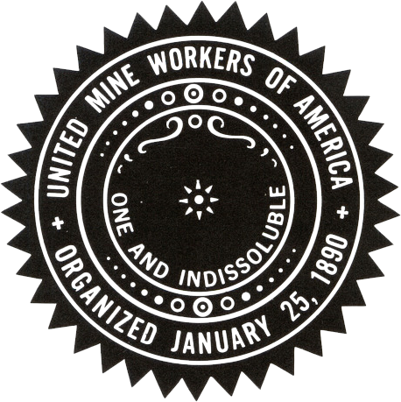
- Who is Mother Jones? Why was she in the coal mining town?

- What was the purpose of the union movement?

- What Constitutional/Democratic rights are contained in the union movement?

- What was the legal age of work in West Virginia?

- How were coal miners paid? How much were they paid?

- What were some “positives” of coal mine work?

- Why was coal important? What did coal do for industrialization?

- How many men in the U.S. were in coal mining?

- How many in West Virginia?

- Why was coal mining in West Virginia attractive to African American southerners?

- How were mining towns segregated?

- Describe the conditions in a “company town” owned by coal mining operators.

- What was “script”?

- What happened when the miners were given raises?

- Who was the most powerful mine operator in the region?

- What made it difficult for mine operators to make a profit?

- Who were the Baldwin-Felts Detectives?

- Who did the courts usually rule in favor of? Private Property owners/operators or workers?

- How did the mine owners break the strike in 1903?

- What were the dangers miners faced?

- How did mine owners block safety legislation from passing?

- What demands did the Union make in response to the deadliest mine disaster?
A.
B.
C.

- What did Miner’s do when their demands were not met?

- How did the governor of West Virginia end the strike?

