PBS Crucible of Empire: The Spanish American War
Act I – The Only Recourse
- List 4 of the new inventions or products that were displayed at the World’s Columbian Exposition in 1893.

- List some of the nations involved with the “New Imperialism” of the 1890s.

- What export from Cuba made the island important to the Spanish empire?

- When did the Cubans begin to rebel against Spain? Why?

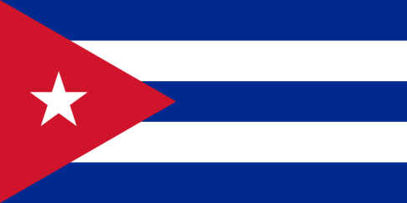
- Who was Maximo Gomez?

- What is the name of the Cuban revolutionary movement? Their flag is on the right.

- Who was Jose Marti? What did he want to achieve in Cuba?

- Why was Marti’s death important to the Cuba Libre movement?

- Why was General Weyler and what did he do?

- What was the name of William Randolph Hearst’s newspaper?

- Describe President William McKinley’s position about going to war with Spain.

- How did Theodore Roosevelt’s (Assistant Secretary of the Navy) position about war with Spain differ from McKinley?

- Alfred Mahan argued for a new Navy for the United States. Why did he think the new navy was important?

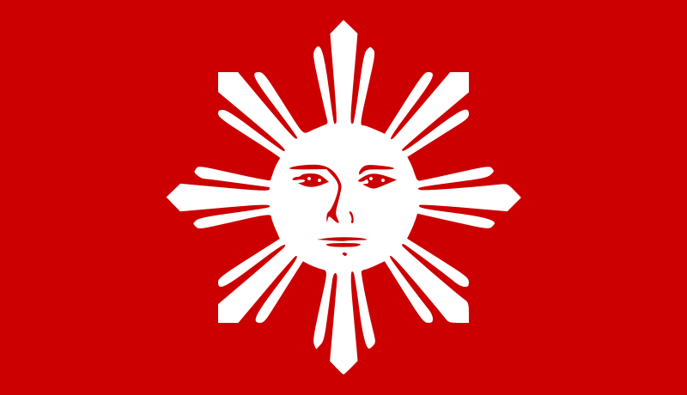
Another flag of the Katipunan different from the one in the film.

- What imperial nation owned the Philippines?

- How many newspapers did President McKinley read per day?

- Who were Emilio Aguinaldo and the Katipunan?

- Describe the effect created by Yellow Journalism in the case of Cuban girl Evangelina Cisneros.

- Why was the U.S.S. Maine sent to Havana Harbor in Cuba?

- What happened to the U.S.S. Maine in February 1898?

- How did America respond?

Act II – They Are Our Redeemers

- How many U.S. sailors were killed during the capture of Manila Bay?

- Where were many of the Spanish-American War movies filmed?

- How many volunteers signed up when President McKinley called for 200,000 volunteers?

- After Theodore Roosevelt Resigned as Assistant Secretary of the navy what military group did he join?

- In what ways were American volunteer soldiers unprepared for war in Cuba?

- What common tropical disease was a danger to U.S. troops?

- Why were many African Americans opposed to participating in the war against Spain?

- Why was the arrival of African-American troops in Tampa Florida controversial?

- Why did Roosevelt’s “Rough Riders” became an infantry regiment while heading to Cuba?

- Who was “Rain in the Face” and “Texas”?

- What structure protected Spanish soldiers at El Caney?

- What hill did the “Rough Riders” actually attack near the San Juan Heights?

- What was special about the U.S. 9th and 10th Cavalry regiments?

- In your opinion was Roosevelt rude to the black soldiers?

- What was ironic about the name of the last Spanish Ship sunk during the war in Cuba?

- How many U.S. Troops died of disease in Cuba?

- Was the amount of death from disease greater than or less than the men who died in combat?

- Explain why it was significant that the United States flag replaced the Spanish flag in Cuba and not the flag of Cuba Libre.

- Were Filipino soldiers happy about having U.S. soldiers aid them in their fight against the Spanish?

Act III – One Man and All Our Institutions

- How many Filipino soldiers were in the battle of Manila?

- Why were Aguinaldo and his followers upset at the surrender of the Spanish in the Philippines?

- How many Filipinos were at the peace negotiations in Paris?

- How many Cubans were there?

- What happened to the Spanish Empire after signing the Treaty of Paris which ended the Spanish-American War?

- Describe the negotiations in the U.S. Congress over the Treaty of Paris. What are the two main opinions being expressed?

- Why did the Filipinos rebel against American soldiers that had helped them defeat the Spanish?

- Did Americans believe the Filipino Insurrection would be a long war against them? Why or why not?

- What methods to Americans use to improve life in Cuba and prevent a rebellion there?
a.
b.
c.

- What would the Teller Amendment have done?

- Were all Americans in favor of becoming an empire by annexing the Philippines?

- Describe guerilla war tactics as used by Filipinos against American soldiers.

- Why did American soldiers call Filipinos “Indians”?

- For what reasons were Theodore Roosevelt nominated for Vice-President in 1900?

- Who was re-elected President of the United States in 1900?

- The Platt Amendment to the Cuban Constitution made Cuba a ________________________ of the United States?

- How was that different than the Teller Amendment?

- What happened to Emilio Aguinaldo?

- How was President McKinley assassinated?

- Who became the new President of the United States?

- When did the Filipino “insurgents” finally end their guerilla war against the U.S.?

- The Philippines became a United States colony. When did it finally get its own independence?

- When the United States military withdrew from Havana Cuba in 1902 what military responsibilities did it
keep?

- Did the U.S. military ever have to go back to Cuba?

- When did Cuba finally receive complete independence?

- What happened to the U.S.S. Maine in 1911?

- Where is the Maine now?

