Using the knowledge you have gained from Chapter 5 Section 3 design a business/corporation of your own. Complete the following tasks on the large white drawing paper using colored pencils/markers.
Side One (Day 1): Brainstorming.
- Create and name a company. Invent a main product line produced by the company.
  - New Inventions do not have to actually work – Just an idea is ok.
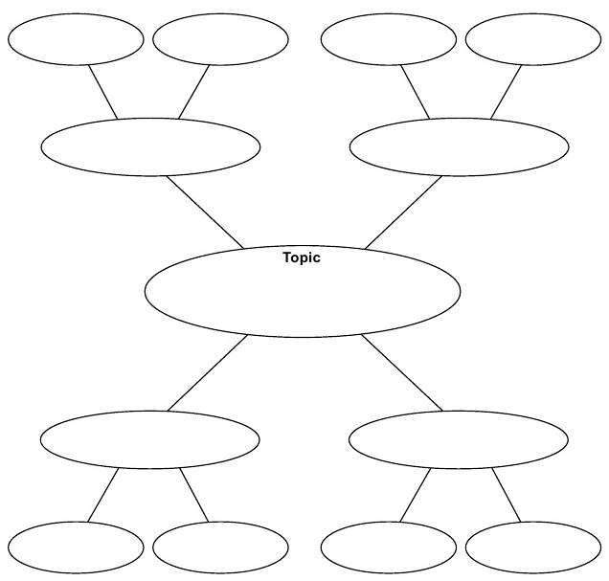
  - If you can’t think of something new, invent an improvement to something you already love.
- Brainstorm with your group creating a word web that contains all of the products related to manufacturing, packaging, selling, and bringing your product to market.

- Make a list of All Fixed Costs associated with your business.
- Make a List of all Operating Costs associated with your business.

Side Two (Day 2-4): Business Model
Fold your poster or draw a line on it creating two sides.
On one half, using your product and company from the brainstorming exercise, graphically illustrate a horizontally integrated business model. Be thorough and artistic.
On the other half, using your product and company from the brainstorming exercise, graphically illustrate a vertically integrated business model.
Be thorough. Be artistic.

