WWII – The War in Europe and North Africa.
Guided Reading Activity – Selected parts of Chapter 14 Sections 2, 4 and 5

DIRECTIONS: Fill in the Blanks In the space provided; write the word or words that best complete the sentence. Refer to your textbook and employ your ability to think to fill in the blanks.

The following can be found in Chapter 14 Section 2 on pages 497 – 499.

1. Joseph Stalin wanted _________________________ to open a second front by attacking Germany from the west, to take the pressure off the Soviet Union.

2. ______________________was very important to Britain because of the __________________ which was the route used by most of Britain’s empire to send supplies to Britain.

3. The German “Afrika Korps” was commanded by __________________________ , a brilliant commander whose success earned him the nickname _______________________ .

4. Under the ___________________________, American cargo ships traveled in groups and were escorted by navy warships, making it much harder for a ______________________________ to torpedo a cargo ship and escape without being attacked.

5. The major battle of _____________________ in southern Russia is considered a turning point in the war because the Russian victory there stopped the German advance.

The following can be found in Chapter 14 Section 4 on pages 508 – 512.

6. The first large Allied invasion of the war was the attack on ____________________________________ .

7. Among the agreements reached at the _______________________________ was the decision to step up the _____________________________ bombing of Germany.

8. Winston Churchill called Italy the ______________________________ of Europe and believed that Italians would quit the war if the Allies invaded their homeland.

9. The ___________________________ in Italy was one of the bloodiest in the war, costing the Allies more than 300,000 casualties.

10. At the Tehran, Iran, meeting between Churchill and Roosevelt, Stalin promised to launch a _____________________ against the Germans when the Allies invaded France in 1944.

11. Stalin also promised that once Germany was defeated, the Soviet Union would declare was on __________________ and help ____________________________.

12. Although the German defenses along the coast of France were formidable, the Allies did have one advantage: _____________________________________________________.

13. To convince the Germans that the Allies were planning to land at Pas-de-Calais, the Allies placed rubber tanks, empty tents, and other _____________________ along the British coast across from Calais.

14. Nearly _____________________ ships carrying more than __________________ soldiers set sail for the coast of Normandy (France) on ______________________.

15. Under intense German ___________________ fire, the American assault almost ________________.

16. By the end of the day, nearly ___________________________ American troops had landed at Omaha beach, and another _______________ had landed at Utah beach. Over _________________ British and Canadian troops were on shore as well.

DIRECTIONS: Analyze the map below, and then answer the following questions in the space provided.
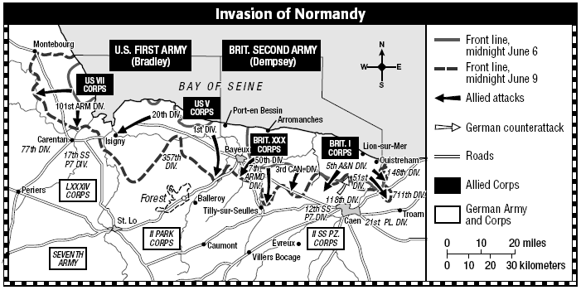

17. From what body of water was the invasion launched? _____________________________________

18. When did the invasion take place? ______________________________________________

19. How many allied attacks are represented on the map? __________________ What symbol is used to identify
them? _______________________

20. What two armies launched the invasion of Normandy? _______________________________________

21. How many front lines are represented on the map? _____________________ How are these identified? ___________________________________________________________________________________________

The following can be found in Chapter 14 Section 5 on pages 518 – 519.

22. While American and British forces fought to liberate _________________________, the ___________________
began a massive attack on German troops in ______________________________.

23. By the first week of March 1945, American troops had fought their way to the ___________________________, Germany’s last major line of defense in the west. As the ___________________ attacked Germany from the West, Russia attacked German from the _________________.

24. Adolf Hitler _____________________________ in his bunker as the Soviets entered Berlin.

25. On May 7, 1945, Germany finally surrendered to the Allies, and the next day was named _______________ which stands for _______________________.

